Week 3 homework

#Loading packages  
library('GGally')  
library('stargazer')  
library('tidyverse')  
library('usdm')

#Loading data   
  
#temperature data file  
tempData <- read.table("https://d37djvu3ytnwxt.cloudfront.net/assets/courseware/v1/592f3be3e90d2bdfe6a69f62374a1250/asset-v1:GTx+ISYE6501x+2T2017+type@asset+block/temps.txt", header = TRUE)  
  
#Crime data file   
crimeData <- read.table("http://www.statsci.org/data/general/uscrime.txt", header = TRUE)  
  
#Set seed for reproducibility  
set.seed(156)  
  
# stargazer(tempData)  
# stargazer(crimeData)

# Question 1

Describe a situation or problem from your job, everyday life, current events, etc., for which exponential smoothing would be appropriate. What data would you need? Would you expect the value of a (the first smoothing parameter) to be closer to 0 or 1, and why?

# Answer

A situation where exponential smoothing might be used is to predict the value of a stock in the stock market. This works because it is time series data. The data that would be needed is a date and a stock price for each date. I would expect the value of a to be closer to 1 as it has less smoothing and gives more value to recent data. This is important as I believe a stocks price is tied to the most recent history.

# Question 2

Using the 20 years of daily high temperature data for Atlanta (July through October) build and use an exponential smoothing model to help make a judgment of whether the unofficial end of summer has gotten later over the 20 years.

# Answer is below:

# Summary of Temperature Data

# Question 3

Describe a situation or problem from your job, everyday life, current events, etc., for which a linear regression model would be appropriate. List some (up to 5) predictors that you might use.

# Answer

A situation that a linear regression model would be useful is to predict the value of a house. Good predictors for this would be square_footage, NumberofRooms, NumberofBathrooms, Plotsize and garagesize.

# Question 4

Predict the observed crime rate in a city. Show your model (factors used and their coefficients), the software output, and the quality of fit.

# Answer is below:

# Summary of Crime Data

# Crime Data Exploration and Transformation

linear models work best with gaussian distributions. Many of the predictors are skewed so I log transformed them to better fit a gaussian distribution. I am plotting both log and non log datasets to see the distributions.

crimeData %>%  
 keep(is.numeric) %>%   
 gather() %>%   
 ggplot(aes(value)) +  
 facet_wrap(~ key, scales = "free") +  
 geom_density() +  
 labs(title = "Crime Data Density Plots")

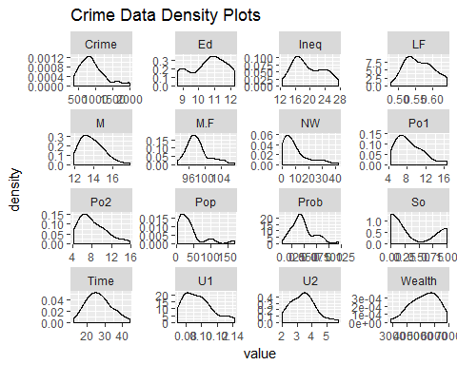

#log transformation to better fit a gaussian distrubution - did not transform column 'SO' as it is logical  
log(crimeData[,c(1,3:16)]) %>%  
 keep(is.numeric) %>%   
 gather() %>%   
 ggplot(aes(value)) +  
 facet_wrap(~ key, scales = "free") +  
 geom_density() +  
 labs(title = "Log Transformed Crime Data Density Plots")

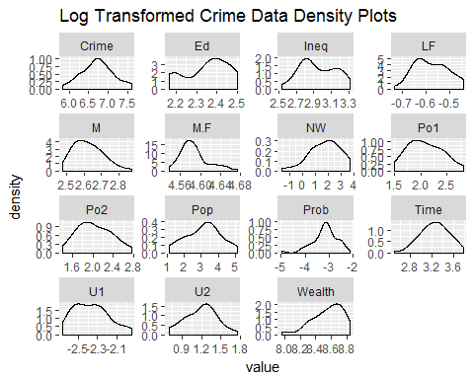

#Building New Log dataset   
logCrimeData <- log(crimeData[,c(1,3:4,6:16)])  
logCrimeData$So <- crimeData$So  
  
#vif(crimeData)

# Test for collinearity

This shows me that po1 and po2 are collinear and there are no need for both in the model. A VIF greater than 10 is a signal that the model has a collinearity problem. Because Wealth and Ineq are near 10 and I believe they are important factors in predicting a crime rate I am leaving them in.

% VIF test M 3.411365  
So 5.342925  
Ed 6.967803  
Po1 118.641813  
Po2 117.546092  
LF 3.743340  
M.F 3.897988  
Pop 2.569876  
NW 4.753696  
U1 6.533978 U2 5.944206  
Wealth 10.897084  
Ineq 12.030316  
Prob 3.328492  
Time 2.739674

# Crime Data Linear Model

Building linear models for both log and normal datasets to compare - chose log-transformed model for best results

crimeModelLog <- lm(Crime ~ ., data = logCrimeData)  
crimeModel <- lm(Crime ~ ., data = crimeData)  
  
# Obtain predicted and residual values  
logCrimeData$predicted <- predict(crimeModelLog)  
logCrimeData$residuals <- residuals(crimeModelLog)  
  
crimeData$predicted <- predict(crimeModel)  
crimeData$residuals <- residuals(crimeModel)  
  
#Creating residual df for plotitng   
modelResiduals <- data.frame(data=(cbind(residuals(crimeModel),residuals(crimeModelLog))))  
colnames(modelResiduals) <- c('Normal', 'Log')  
  
#summary to see accuracy   
summary(crimeModelLog)

##   
## Call:  
## lm(formula = Crime ~ ., data = logCrimeData)  
##   
## Residuals:  
## Min 1Q Median 3Q Max   
## -0.37220 -0.12001 0.00339 0.10944 0.36213   
##   
## Coefficients:  
## Estimate Std. Error t value Pr(>|t|)   
## (Intercept) -4.05111 8.53640 -0.475 0.638317   
## M 1.56933 0.48985 3.204 0.003067 **   
## Ed 2.15094 0.54736 3.930 0.000427 ***  
## Po1 0.77794 0.19543 3.981 0.000370 ***  
## LF 0.61067 0.67478 0.905 0.372230   
## M.F -2.38907 1.82213 -1.311 0.199143   
## Pop -0.07614 0.04817 -1.581 0.123813   
## NW 0.10791 0.04445 2.428 0.021002 *   
## U1 -0.12685 0.31390 -0.404 0.688826   
## U2 0.44557 0.22457 1.984 0.055883 .   
## Wealth 0.66766 0.39219 1.702 0.098374 .   
## Ineq 1.59115 0.35365 4.499 8.46e-05 ***  
## Prob -0.30382 0.09638 -3.152 0.003506 **   
## Time -0.26841 0.16755 -1.602 0.118997   
## So 0.06321 0.13263 0.477 0.636896   
## ---  
## Signif. codes: 0 '***' 0.001 '**' 0.01 '*' 0.05 '.' 0.1 ' ' 1  
##   
## Residual standard error: 0.178 on 32 degrees of freedom  
## Multiple R-squared: 0.8695, Adjusted R-squared: 0.8124   
## F-statistic: 15.23 on 14 and 32 DF, p-value: 2.404e-10

#coefficients and formula   
crimeModelLog

##   
## Call:  
## lm(formula = Crime ~ ., data = logCrimeData)  
##   
## Coefficients:  
## (Intercept) M Ed Po1 LF   
## -4.05111 1.56933 2.15094 0.77794 0.61067   
## M.F Pop NW U1 U2   
## -2.38907 -0.07614 0.10791 -0.12685 0.44557   
## Wealth Ineq Prob Time So   
## 0.66766 1.59115 -0.30382 -0.26841 0.06321

# plotting the residuals

Ensuring that my residuals are normally distributed. A normally distributed residual plot is a sign of a good linear model. The log model is closest to normal distribution.

#qqplots to determine if residuals are normally distributed. Log transformed model has a better looking distribution indicating to me that it is the better model.   
modelResiduals %>%   
 ggplot(aes(sample=modelResiduals$Log)) +  
 stat_qq() +  
 labs(title = "Log Transformed Residuals")

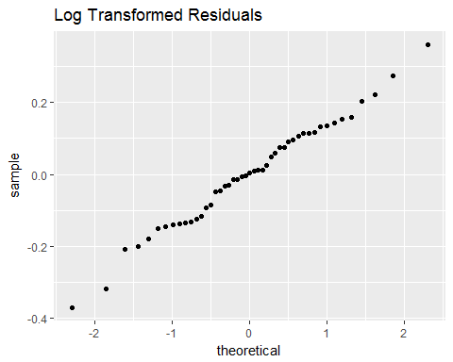

modelResiduals %>%   
 ggplot(aes(sample=modelResiduals$Normal)) +  
 stat_qq() +  
 labs(title = "Normal Residuals")

